

**جــامـعـة الإسراء الخــاصــة**

**كـليـة تكـنولوجيـا المعلومـات**

**Isra University**

**Faculty of IT**



**Second Semester 2023/2024**

|  |  |  |
| --- | --- | --- |
| Course Title: Database | **Course No.: 06013130** | **HW No : 1** |
| **Submitted to: Dr. Maher Abuhamdeh** | | |
| **Student Number:**  **AB1199** | **Student Name:**  حمزة خالد مسلم | **Date:**  **29/03/2024** |

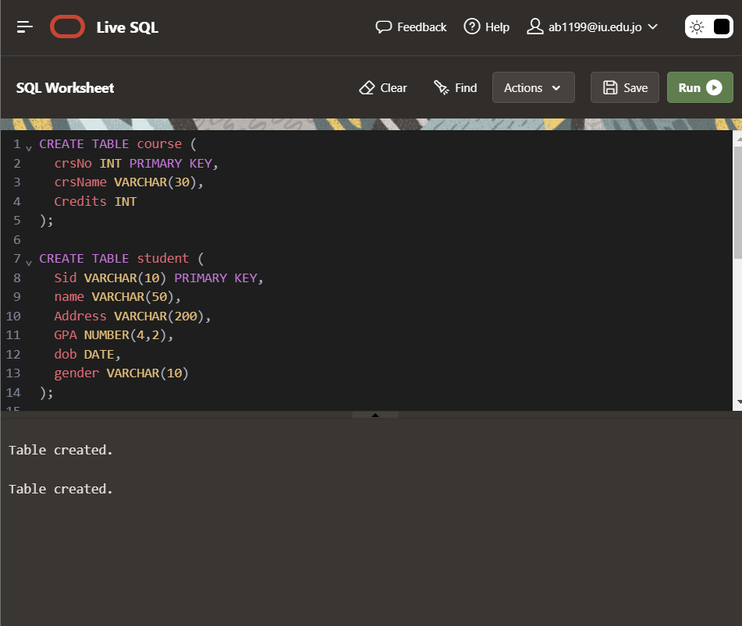

Take Screenshot and attached in cover page

